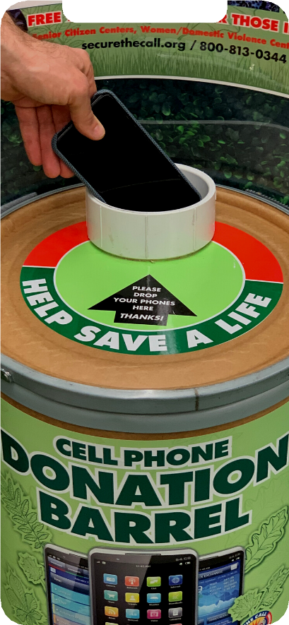
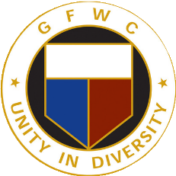
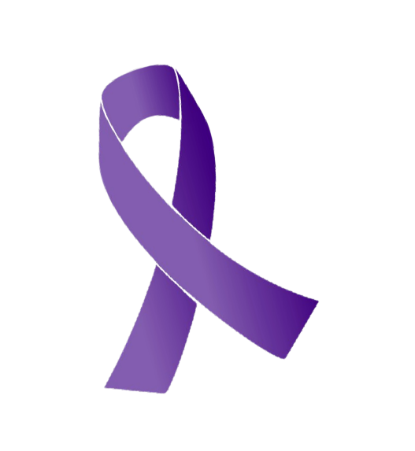
DONATE YOUR OLD PHONES & TABLETS
GFWC National Cell Phone Recycling Drive

The GFWC Club name here and the General Federation of Women's Clubs have teamed up with Secure the Call to collect used and unwanted cell phones and tablets. These devices find new life as emergency-only phones, which Secure the Call distributes to Domestic Violence Services across the country.

By the Numbers
Each day more than 20,000 phone calls are placed to DV hotlines nationwide

400,000 phones are discarded in the US daily

To date, Secure the Call has distributed over 40,000 devices to Domestic Violence Services

How you can help
Please help us reach our goal of collecting 5,000 phones through February 2023.
If you have any old devices, please bring it to the drop box location listed below.
If you wish to send your devices directly to Secure the Call - please visit their website for a mailing slip.

Local Contact:
Your contact email here

Drop Off
Address here.
Questions?

Phone here (local)

