Jean Guarino
Ousamequin Club, Bridgewater, MA
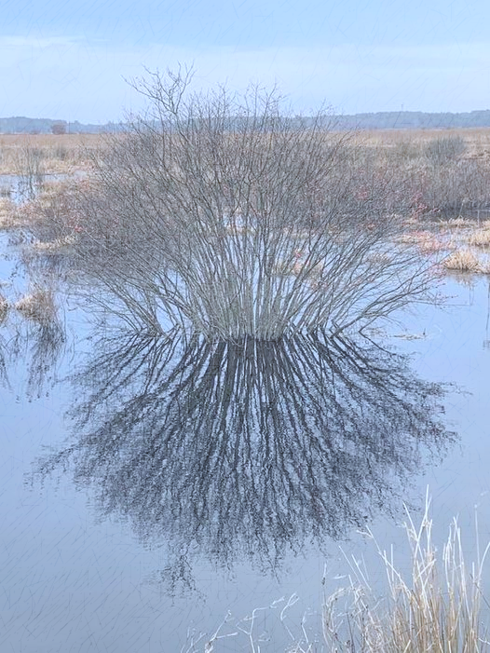
GFWC MA

Winter Images

Leaves hanging on the beech tree,
which have gone from green to gold to papery white
Bare trees, snow and ice glistening in the V of the branches,
The greens, grays, and golds in the woods
Waves of water artistically frozen at the river’s edge
winter reflections, red and orange berries
a barren beach.
People wrapped up in their coats, hats, and gloves.
Rushing along in the winter wind and snow or icy sleet
Focusing on their business or
Strolling along the barren beach.
Feeling the apricity of the winter sun on their faces
Laughter over tea and a biscuit with a friend,
The warmth of a hand-knitted afghan,
a cup of coffee and a good book.

The Burrage, Hanson, MA jeg 2023

